**APACHE TOMCAT 9 METRICS FROM REMOTE EC2**

1. **Launch a t2.micro instance with ubuntu 20.**

**Security Group**:

*SSH Port:22 MyIp*

*All TCP Port:0 - 65535 0.0.0.0/0*

1. **Install Apache tomcat9 on Ec2 instance.**

sudo apt-get update

sudo apt install tomcat9 tomcat9-admin

ss -ltn

sudo systemctl enable tomcat9

sudo ufw allow 8080/tcp

1. **Deploy a demo app on apache server**

git clone <https://github.com/Shivamrathi001/Demo-website.git>

cd Demo-website

**Apache location for simple html website:**

sudo cp -r ./* /var/lib/tomcat9/webapps/ROOT

sudo ls /var/lib/tomcat9/webapps/ROOT

**Reload the apache server**

sudo systemctl restart tomcat9

1. **Elastic Agent on Remote EC2**

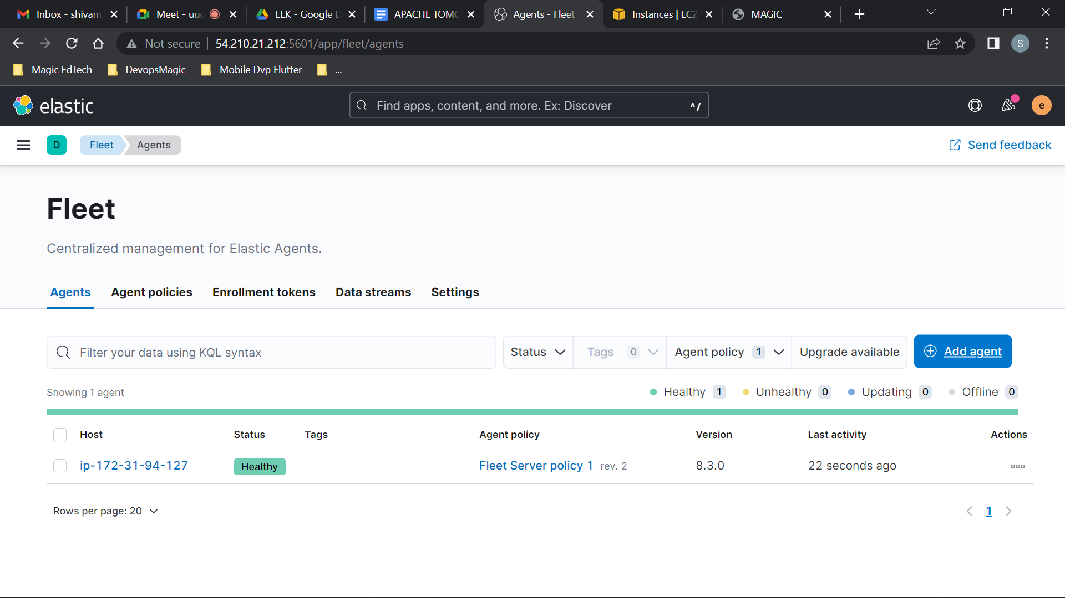

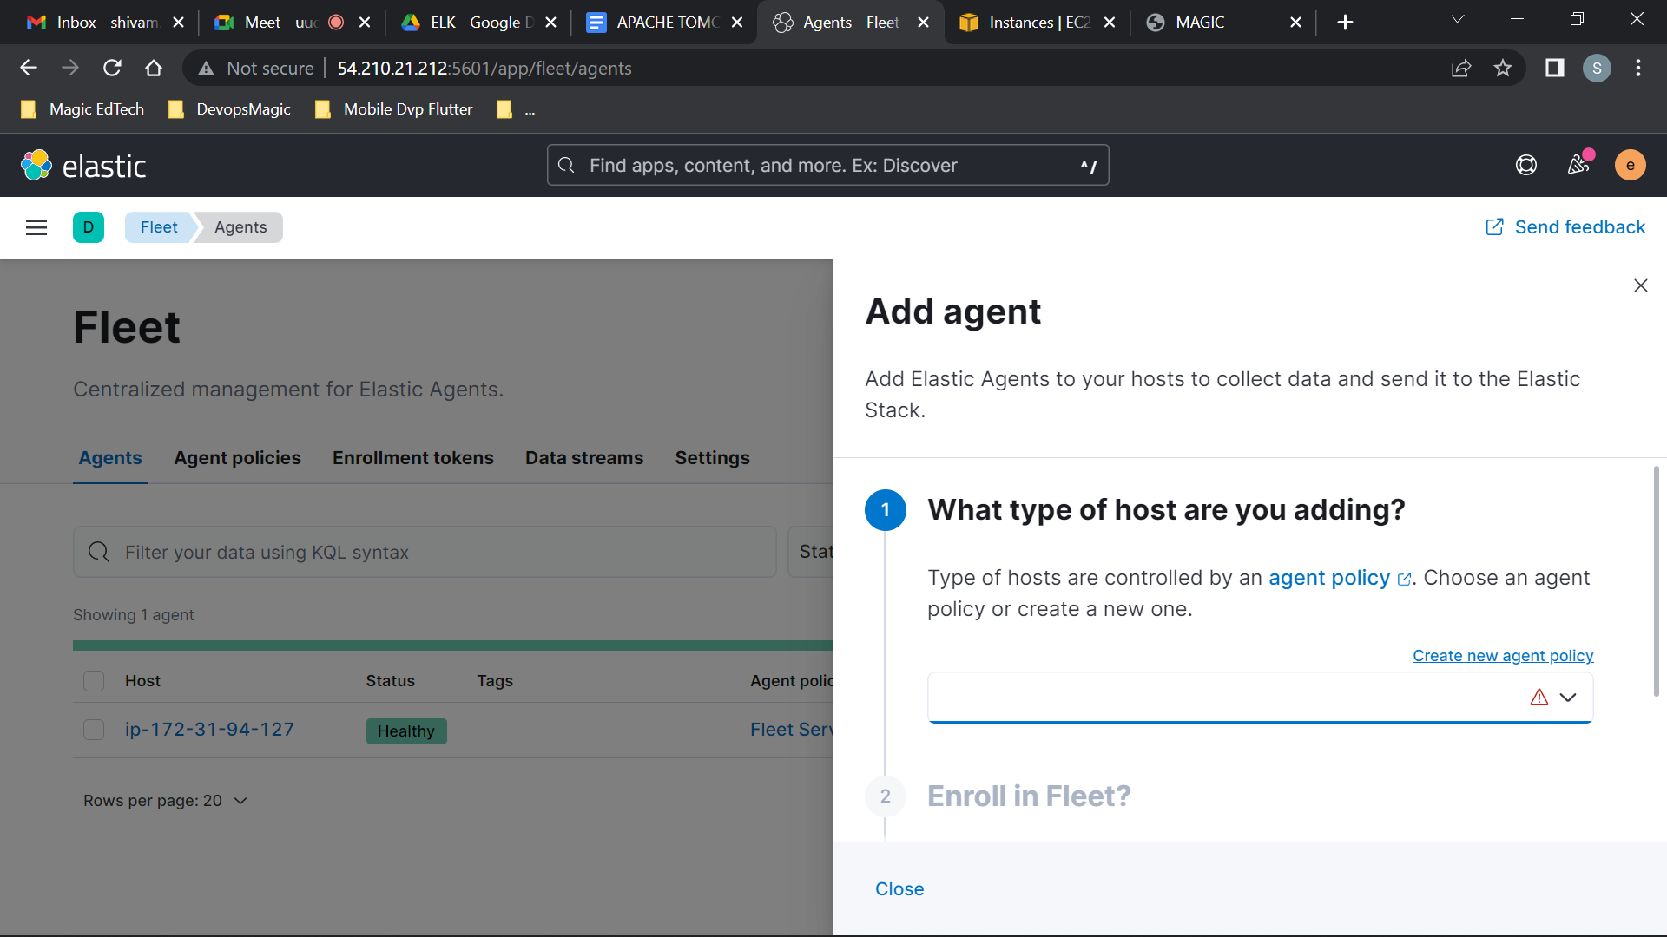

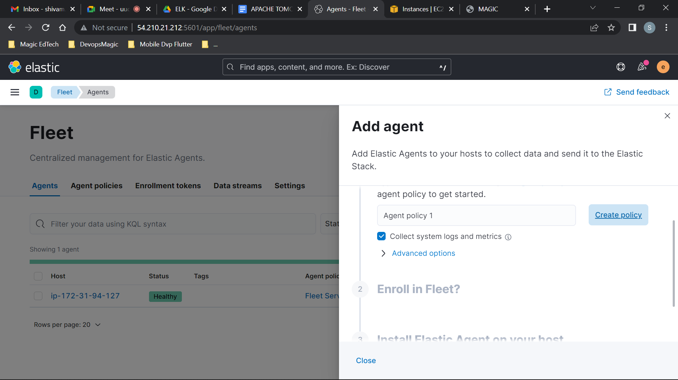

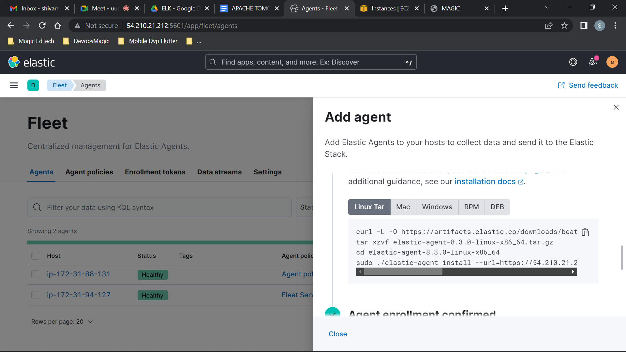

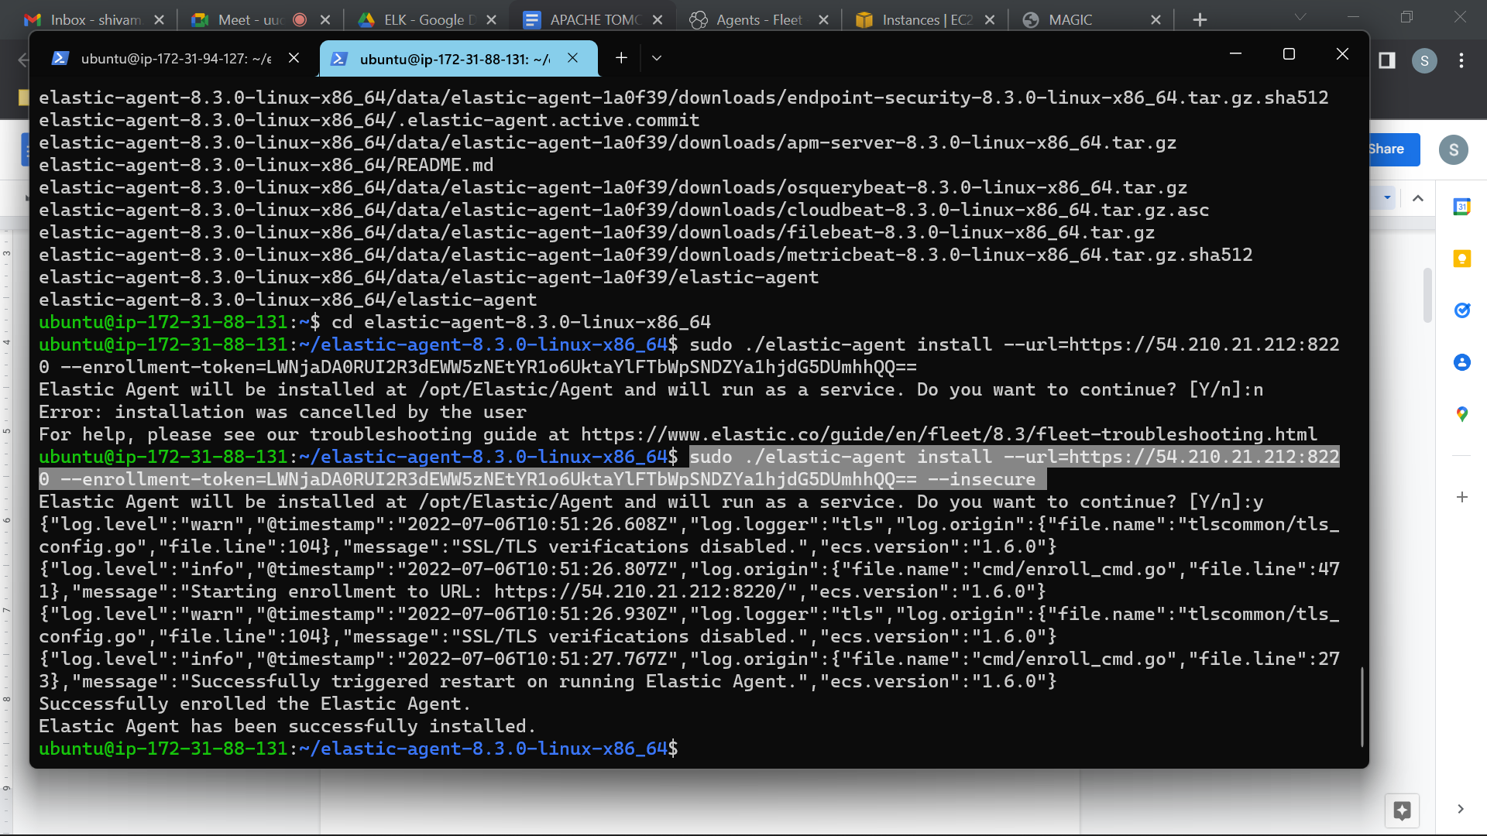

***Add --insecure at the last in the ./elastic-agent install command.***

1. **Start Apache, Check observability**

After Installing elastic agent on remote EC2 , add the apache integration to the remote Agent policy.

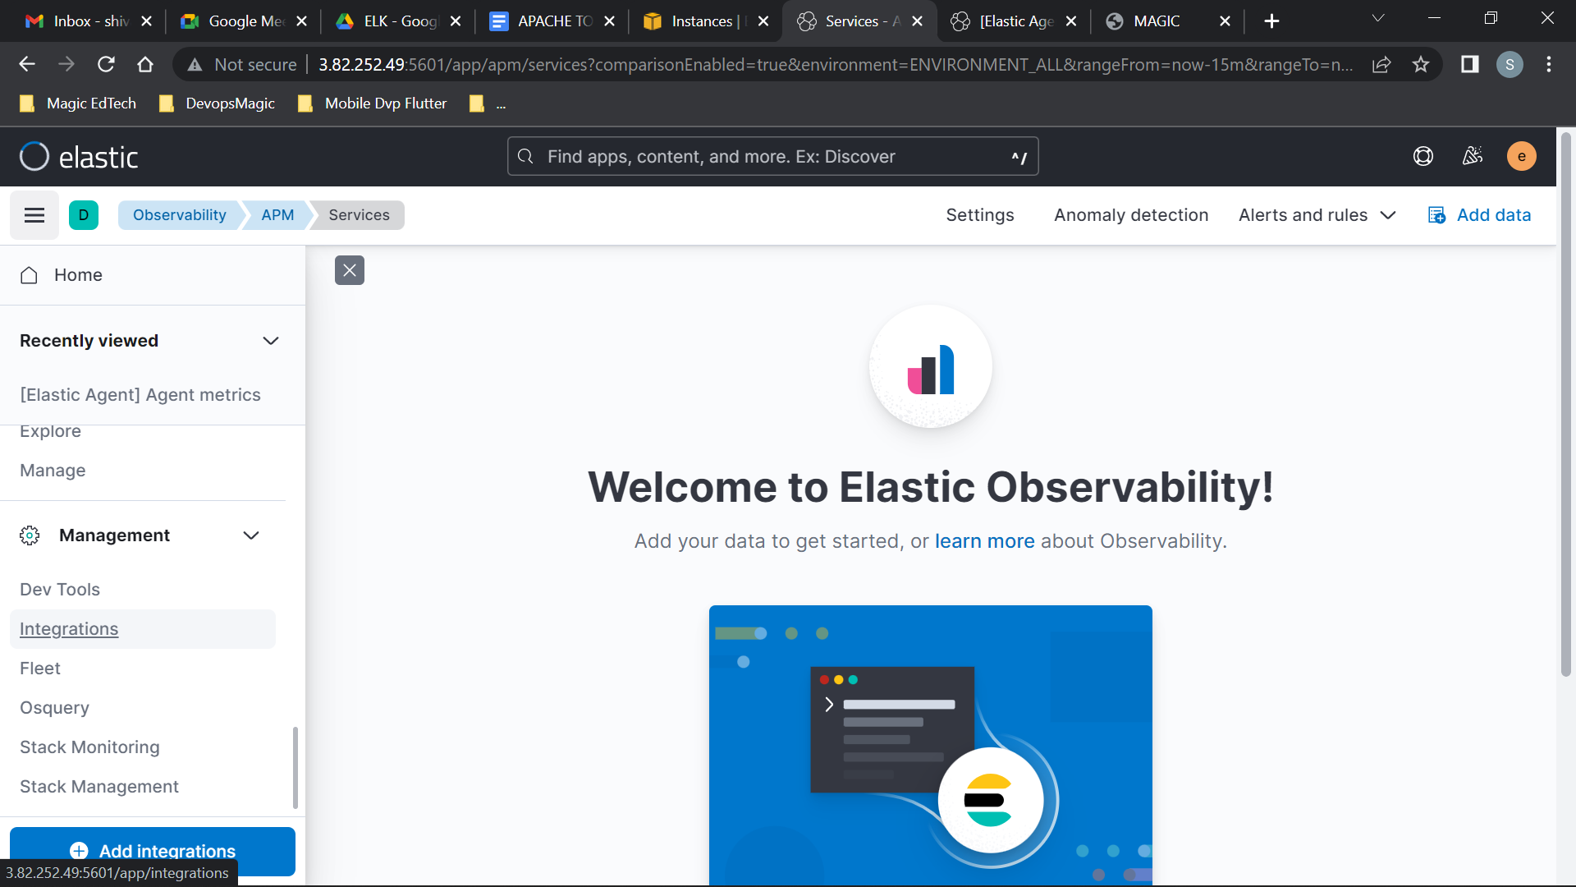

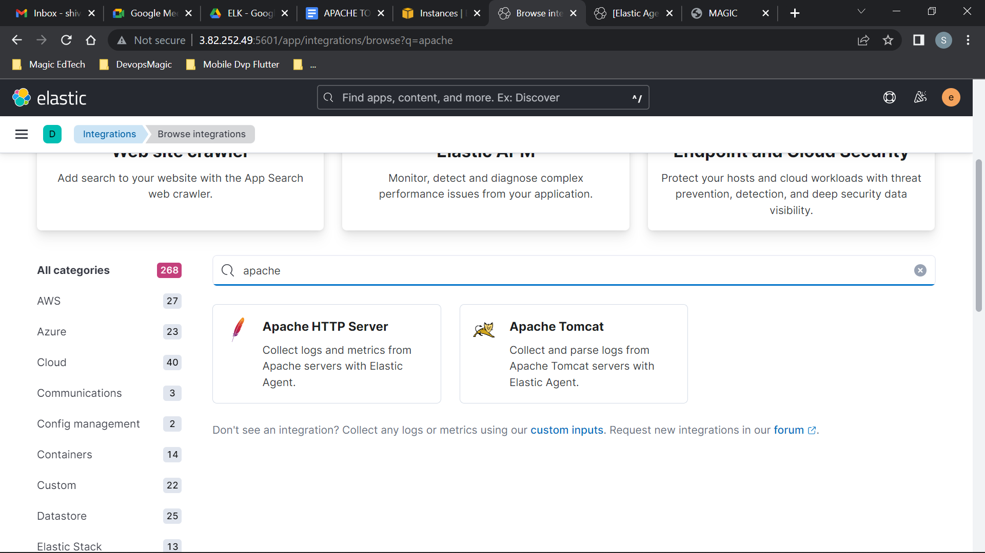

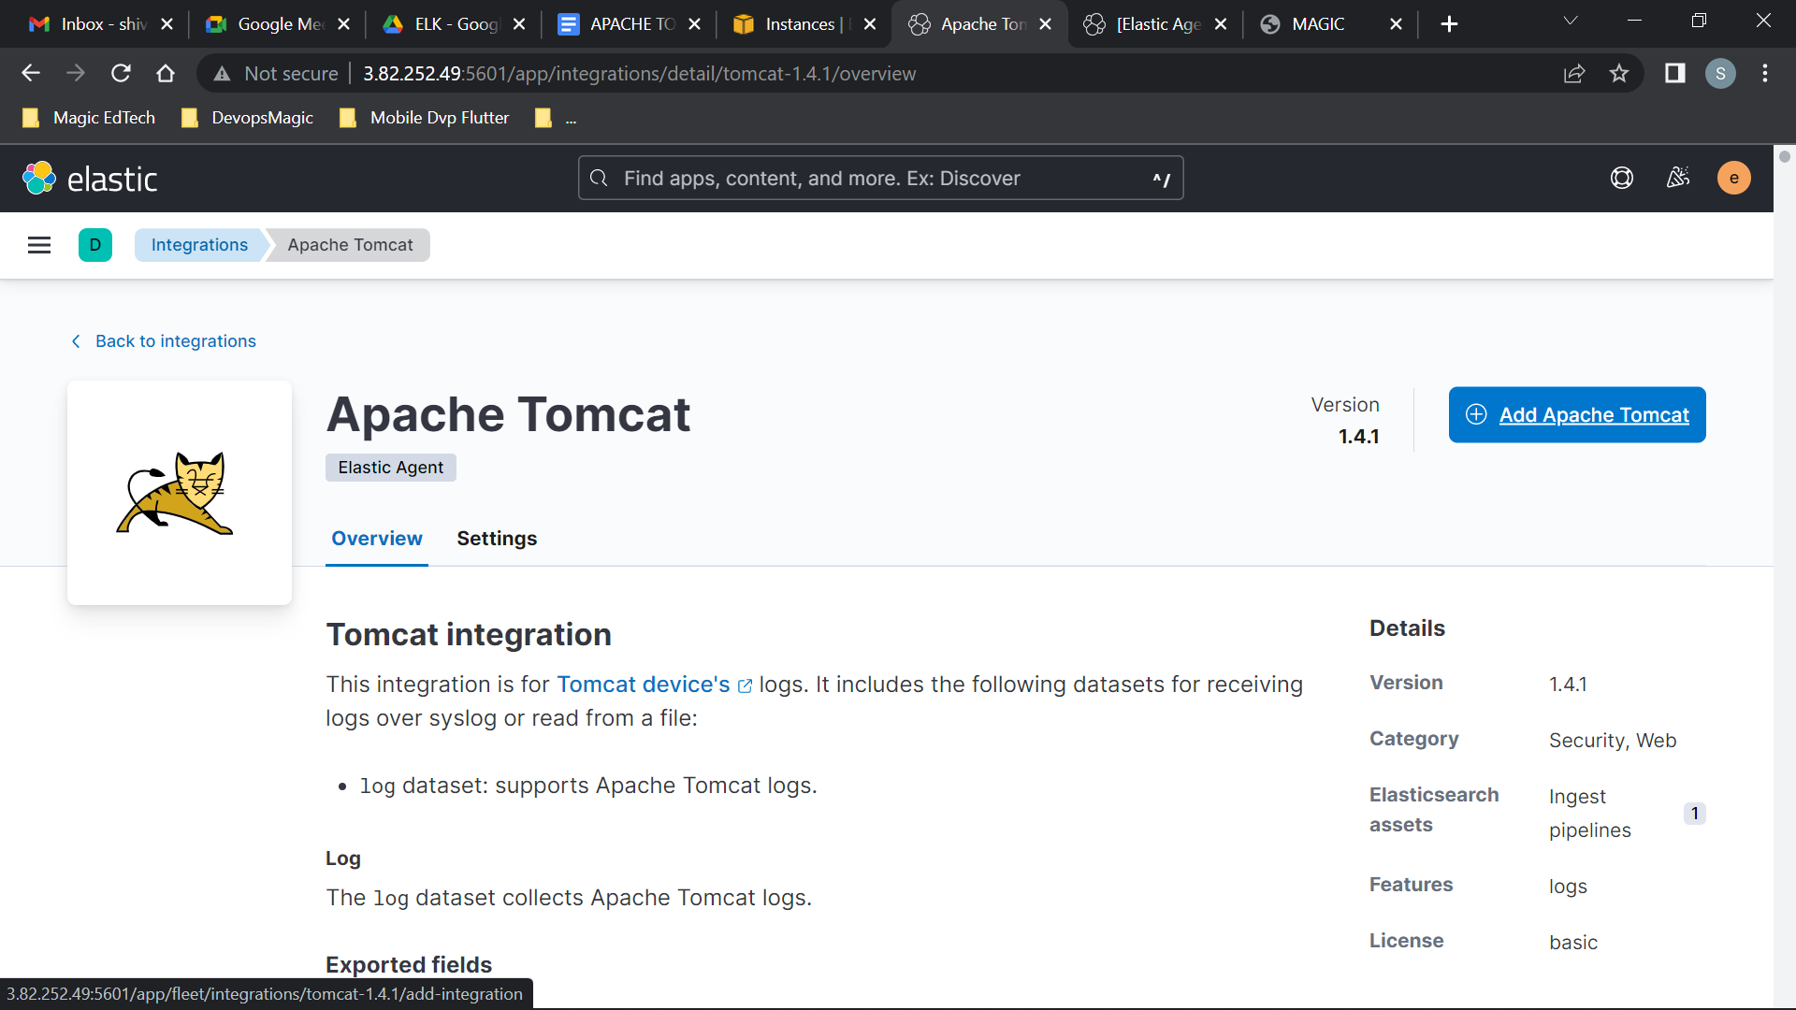

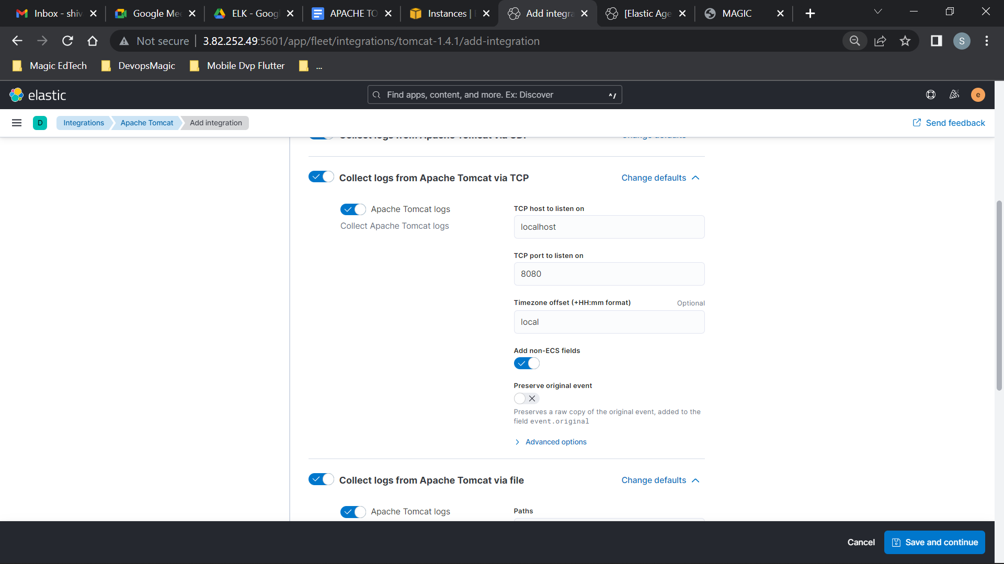

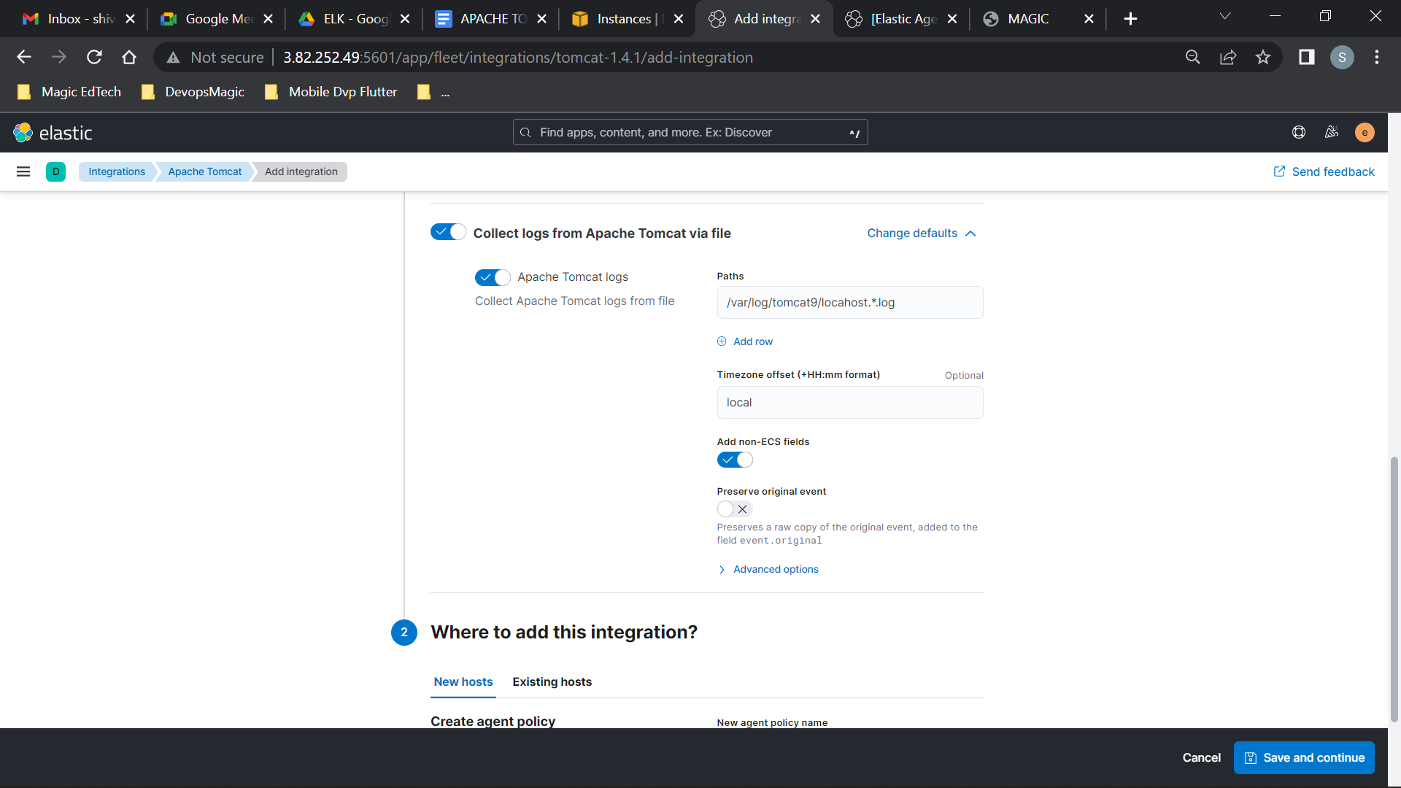

/var/log/tomcat9/localhost.*.log

